tor bay harbour

Emergency Plan

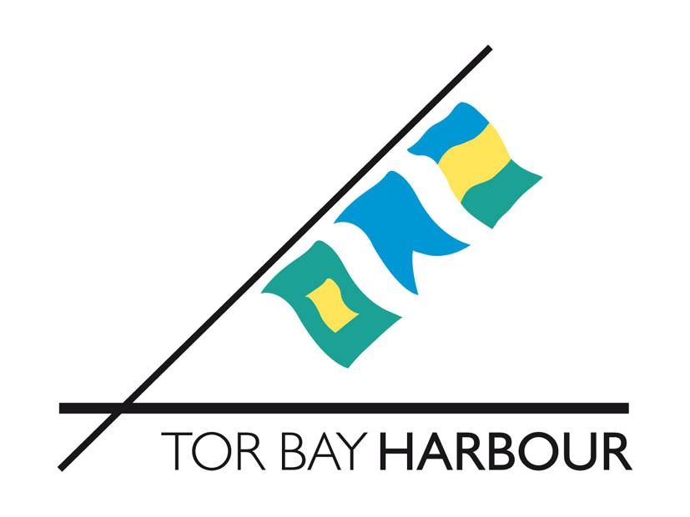

Immediate Action

In the event of an emergency go to Chapter 4

Town Hall, Castle Circus,
Torquay TQ1 3DR

TITLE: Tor Bay Harbour Emergency Plan

PREPARED BY:

Chris Packer, Emergency Planning Officer
Adam Parnell, Tor Bay Harbour Master

DATE:

December 2018

REVIEW PERIOD:

3 years or following a major incident requiring the plan to be implemented

RESPONSIBLE PERSON

Executive Head of Tor Bay Harbour Authority

RECORD OF AMENDMENTS

Amendment Number | Amendment Date | Date Inserted | Initials
01 | 01/03/14
02 | 10/09/14
03 | 16/10/15
04 | 09/12/15

DISTRIBUTION

Chief Executive: Torbay Council
Chairman: Tor Bay Harbour Committee
Torquay Harbour Office
Paignton Harbour Office
Brixham Harbour Office
Tor2 24-Hour Control
Torbay Council Emergency Planning
Torquay Marina
Brixham Marina
Brixham Trawler Agents

Additional copies distributed at the discretion of the Executive Head of Tor Bay Harbour Authority

CONTENTS

CHAPTER 1 - Introduction

Aim

References

CHAPTER 2 - Tor Bay Harbour Authority

Responsibilities

Harbour limits

Vessel reporting

Pilotage

Dangerous substances in harbour

Specific hazards

Beaching
Call-out procedure
Communications
Harbour resources
Third party resources
News media
Shift rota
Health and safety
Administration
CHAPTER 3 - Command and Control
SECTION 1 - Incidents at sea in Tor Bay (including enclosed harbours)
Harbour Master
HM Coastguard
Secretary of States Representative (SOSREP)
Harbour Incident Management Team
Torbay Council Emergency Management Team
Marine Response Centre
Salvage Control Unit

Response Co-ordinating Centre (RCC)

Environment Group

MCA Chemical Strike Team

Temporary Exclusion Zones (TEZ)

Temporary Danger Area (TDA)

SECTION 2 - Incidents on-shore (including the harbour estate)

Harbour Master

HM Coastguard

Emergency Services

Emergency Functions

Command and Control - Schematic

CHAPTER 4 - Emergency Response

Initial Notification

Initial Response Flowchart
Immediate Action Check List
Incident Assessment Checklist
Notification Checklist
Action Sheets
Harbour Incident Management Team - Draft Agenda
Incident Response – Aide Memoir

ANNEX A - Harbour Plans

ANNEX B - Tor Bay Harbour Authority Contact

ANNEX C - Communications Plan
ANNEX D - Spare

ANNEX E - Tor Bay Harbour Authority Emergency Operations Log
ANNEX F – Pollution Report CG77

CHAPTER 1

INTRODUCTION

AIM
This plan outlines the contingency arrangements for responding to incidents occurring within or affecting the Tor Bay Harbour area.
It is directed at Tor Bay Harbour personnel and those in other organisations with responsibility for the management of emergencies or incidents.
The plan aims to outline procedures which seek to:
- Ensure a co-ordinated and appropriate response to any emergency within or adjacent to the Harbour Authority’s area of jurisdiction.
- Achieve compatibility with other Torbay Council plans and of other external organisations.

The basic objectives of the Authority’s response to emergency incidents will be to:
- Save life
- Prevent escalation of the emergency
- Ensure safety of navigation
- Minimise environmental impact
- Return to normal
- Collect evidence for investigation and enforcement proceedings

This plan needs to be reflected in procedures for front line staff. Staff also need to be trained and exercised in the procedures.

The Tor Bay Harbour Emergency Plan is supplemented by a Port Security Plan which outlines the response to bomb threats, and addresses responsibilities under the International Ship and Port Security (ISPS) code and Ship and Port Facility (Security) Regulations 2004.

REFERENCES

Reference has been made to the following:

- Tor Bay Harbour Bye-Laws
- Tor Bay Harbour Authority Marine Safety Management System
- Tor Bay Harbour Oil Spill Contingency Plan
- Torbay Council Major Emergency and Business Recovery Plan
- Torbay Council Coastal Oil Pollution Plan
- Torbay Council Coastal Flooding Major Incident Plan
- Dangerous Substances in Harbour Areas Regulations 1987 (SI No 37)
- Maritime and Coastguard Agency National Contingency Plan for Marine Pollution from Shipping and Offshore Installations

Learning points from the response to the incident involving the merchant vessel Bothnia Stone in Tor Bay Harbour in October 2002 and the MSC Napoli incident in 2007 have also been incorporated into this plan.

CHAPTER 2

TOR BAY HARBOUR AUTHORITY

RESPONSIBILITIES

The Tor Bay Harbour Act 1970 confers upon the Authority certain statutory duties and powers relating to the safe and efficient management of Tor bay Harbour.

In particular these duties include taking measures to secure the safety of navigation, and as a consequence, for developing plans to manage any incident or emergency which affects or potentially affects that safety of navigation within or adjacent to its area of jurisdiction.

HARBOUR LIMITS

The Harbour limits are defined by the Tor Bay Harbour Act 1970. (See map at Annex A)

The harbour limits are as follows:

The area below the level of high water enclosed by an imaginary line drawn from the point at which the northern boundary of the borough meets the coast to a point one-half of a nautical mile true east, thence to a point one-half of one nautical mile true east of Hope’s Nose, thence to a point one nautical mile true east of Berry Head and thence direct to Sharkham Point.

VESSEL REPORTING

Vessels should report in accordance with the information provided in the Admiralty List of Radio Signals (ALRS).

PILOTAGE

Compulsory pilotage is provided under contract by Brixham Pilots/Marine & Towage Services.

DANGEROUS SUBSTANCES IN HARBOUR

The Dangerous Substances in Harbour Areas Regulations 1987 requires the master or agent of a vessel, or the operator of other forms of transport, to give at least 24 hours’ notice to the Harbour Master before bringing dangerous substances into harbours or the harbour area. [The Merchant Shipping (Dangerous Goods and Marine Pollutants) Regulations 1997 defines the various categories of substances classified as Dangerous and refers to International Maritime Dangerous Goods Code (IMDG) for individual definitions and classifications. Part V of the Dangerous Substances in Harbour Areas Regulations 1987 covers Liquid Dangerous Substances in Bulk].

Before dangerous substances are handled in harbours or the harbour area, the harbour authority must prepare an emergency plan for dealing with emergencies that involve or could affect dangerous substances that are brought into or are handled in the harbours or harbour area. The plan should be written in consultation with the emergency services and any other appropriate bodies.

Dangerous Substances – Emergency Plan

The plan should ensure that:

- Rapid means of communication are available with the emergency services
- Adequate means of escape from the berth are provided
- The master of the vessel loading or unloading is notified of the means by which the alarm can be raised, and have written notice of the signals to be used in an emergency, and the arrangements for summoning the emergency services.
- Information is immediately available to the emergency services on:
The identity, quantity and location of each substance on the berth;
The nature of the dangers to which each substance may give rise and the
emergency action that should be taken.
- The master of a vessel shall immediately notify the Harbour Master and berth operator of any untoward incident that has occurred on the vessel
- The berth operator shall immediately notify the Harbour Master and master of any untoward incident which occurs on the berth
- Where an incident occurs, the person controlling the handling operation shall stop the operation and report the incident to the Harbour Master, the berth operator, the master of any vessel which might be affected, and where appropriate the emergency services.
- The operation will not resume until corrective measures have been taken to make it safe to resume the operation, and the Harbour Master has authorised resumption of the operation.

SPECIFIC HAZARDS

At sea (within harbour limits)

- Oil or other pollution hazards
- Emergencies (collision, grounding, beaching, sinking, fire and explosion) on:
- Vessels with hazardous cargoes
- Vessels at anchor in Tor Bay
- Vessels underway in Tor Bay
- Vessels alongside or on moorings
- Dangerous vessels entering Tor Bay
- Emergencies outside of Harbour area
- Unexploded ordnance
- Hazardous objects afloat in Tor Bay
- Emergency situations on leisure craft or passenger-carrying pleasure craft

Within enclosed harbours

- Oil or other pollution hazards
- Unexploded ordnance
- Emergencies (collision, grounding, sinking, fire, explosion) on:
- Vessels with hazardous cargoes
- Vessels at anchor
- Vessels underway
- Emergency situations on leisure craft or passenger carrying pleasure craft
- Fires
- Vessels alongside with hazardous cargoes
- Hazardous objects washed ashore

On-shore within harbour area

- Vessel grounding or stranding
- Oil or other pollution hazards
- Unexploded ordnance
- Hazardous objects washed ashore
- Refuelling facilities
- Flooding
- Fire

BEACHING/GROUNDING

Under certain circumstances it may be necessary to deliberately ground a vessel to prevent or reduce the risk of injury, death, or damage to the environment. Where time allows, any decision will be taken in liaison with the Council, MCA, Environment Group, vessel owner and Master.

Locations for beaching will depend on the presenting hazard and the size of the vessel.

CALL-OUT PROCEDURE

Relevant personnel will be notified through the Tor Bay Harbour Authority Cascade - See Annex B

If Torbay Council resources are required, officers should be contacted in accordance with the Council’s Emergency Cascade Procedures.

COMMUNICATIONS

See Communications Plan at Annex C

Refer to the Admiralty List of Radio Signals

HARBOUR RESOURCES

Counter Pollution Assets

A stockpile of Tier 1 counter pollution equipment is maintained at each enclosed harbour. Similarly, the Harbour Authority’s Tier 2 Contractor (Adler and Allen) is equipped with a comprehensive inventory of equipment.) Details are contained within the Tor Bay Harbour Oil Spill Contingency Plan.

Waterborne Assets

Oscar 4 – MCA Code of Practice Category 3

- 6.2m fast rigid inflatable boat (RIB).
- Vessel normally operates when requested during daylight hours.
- Carries 6 persons including crew

Functions

- Beach and harbour patrols
- Incident response
- Search and safety
- Pollution response

Oscar 4 may be tasked by the Harbour Master to assist HM Coastguard with Search and Rescue or other incident response. Control is maintained by the Harbour Master when tasked in support of HM Coastguard.

Our Fortune - MCA Code of Practice Category 3

- 6.7 m Fibromar type approved hull. 54 horse power Yanmar inboard engine.
- Use normally when requested in daylight hours.
- To carry 6 persons including crew
- Fitted salvage pump and forward capstan winch.

Functions

- Assistance to beach and harbour patrols.
- Pollution response.
- Incident response.
- Towing small vessels and objects within enclosed harbours.

Control of any tasking to be confirmed and authorised by duty Harbour Master.

Oscar 4 or Our Fortune may be tasked by the Harbour Master to assist HM Coastguard with Search and Rescue or other incident response. Control is maintained by the Harbour Master when tasked in support of HM Coastguard.

THIRD PARTY RESOURCES

Marine & Towage Services Group Ltd [Brixham Office] (MTS)
Formerly, Torbay & Brixham Shipping Agents Ltd

Pilot Boats

Use of MTS Pilot Boats are covered by contractual arrangement

NEWS MEDIA

Most incidents will attract interest from the news media. Torbay Council’s Communications Team should be notified of any significant incidents.

Guidance also exists in Torbay Council's Major Emergency Plan.

SHIFT ROTA

In the event that staff are required to work over a 24-hour period, a shift system must be implemented.

It is anticipated that a shift will extend for a maximum of 6 hours. A second and a third shift will be expected to take over for further periods of 6 hours respectively. The three shifts would then alternate for the duration of the emergency until replacements can be brought in. Time should be allowed for hand-overs.

Example Duty Roster

 | 07:30 – 14:00 | 13.30 – 20:00 | 19:30 - 0200 | 01:30 - 0800
Monday | Shift 1 | Shift 2 | Shift 3 | 1
Tuesday | 2 | 3 | 1 | 2
Wednesday | 3 | 1 | 2 | 3
Etc.

HEALTH AND SAFETY

Health and Safety considerations should be taken into account both in planning and responding to incidents. Managers must assess health and safety risks and put in place appropriate controls in accordance with current health and safety legislation and policies.

A core feature of all Health and Safety Regulations is the requirement to undertake a suitable and sufficient risk assessment as a pre-cursor to introducing the necessary control measures to eradicate or minimise exposure to risk.

ADMINISTRATION

Expenditure

An accurate record must be kept of all expenditure during an emergency to ensure that all incurred costs are repaid promptly.

Records

A log must be kept of all decisions and actions taken, including details of financial expenditure relating to the emergency. An example Operations Log Sheet is shown at Annex E.

CHAPTER 3

COMMAND AND CONTROL

SECTION 1 - INCIDENTS AT SEA IN TOR BAY (Including Enclosed Harbours)

(See Section 2 for incidents ashore)

HARBOUR MASTER

The Harbour Master is responsible for the control and co-ordination of all incidents (other than the search and rescue elements, and counter terrorism) occurring inside the harbour authority’s jurisdiction.

Powers to give general directions

All Harbour Masters have powers to direct the time and manner of a ships entry into, departure from, or movement within a harbour. This gives a Harbour Master the power to regulate the day-to-day movements within the harbour.

It does not permit the Harbour Master to prohibit or insist upon entry. However, the Dangerous Vessels Act 1985 does permit a Harbour Master to prohibit entry or require departure from a harbour if in his opinion the condition of that ship, or the nature of anything it contains, is such that its presence in the harbour might involve a grave and imminent danger to the safety of persons or property or risk that the ship may, by sinking or foundering in the harbour, prevent or seriously prejudice the use of the harbour by other ships. He must have regard to all the circumstances and to the safety of any person or ship. The Secretary of States Representative is empowered to exercise the powers of the Secretary of State to over-rule such directions (See below).

HM COASTGUARD

Responsible for the co-ordination of civil maritime search and rescue operations throughout the coastal and offshore waters of the UK, including the area within Tor Bay Harbour limits.

Local response is co-ordinated from the UK Coastguard Operations Centre (CGOC).

SECRETARY OF STATES REPRESENTATIVE (SOSREP)

The Secretary of States Representative (SOSREP) is appointed by the Government to provide overall direction for all marine pollution incidents involving the salvage of ships or offshore installations that require a national response.

SOSREP is empowered to exercise the powers of the Secretary of State in respect of dangerous vessels and/or ships that are required to be moved.

SOSREP may act in support of the response to an incident without intervention.

Where SOSREP does intervene, the Harbour Master will require the transfer of responsibility for managing the incident response to be formally documented before relinquishing overall control of at-sea operations.

HARBOUR INCIDENT MANAGEMENT TEAM

In a significant event, a Harbour Incident Management Team will be convened and chaired by the Harbour Master to co-ordinate and direct the incident response.

Harbour Incident Management Team Location

Depending on the location of the incident, the team will be based at either the Torquay or Brixham Harbour meeting room.

Harbour Incident Management Team Membership

Depending on the nature of the incident, the Harbour Incident Management Team may include representatives from the following organisations:
Harbour Authority
Torbay Council
Emergency Services
HM Coastguard
Harbour organisations as appropriate
Marine & Towage Services
Oil Company
Vessels owners/agent
MCA
SOSREP
Salvor
Tier 2 Contractor
Devon & Severn Inshore Fisheries Conservation Authority
Natural England
Environment Agency
MMO
Torbay Coast and Countryside Trust
Wildlife/conservation organisations
Torbay Seaways & Stevedores

TORBAY COUNCIL EMERGENCY MANAGEMENT TEAM

In significant incidents, Torbay Council will set up an Emergency Management Team to strategically manage the incident, to support the co-ordinating Duty Harbour Master, and to provide command and control of other resources of the council that may be required to mitigate the effects of the incident (Refer to Torbay Council Major Emergency Plan).

MARINE RESPONSE CENTRE

In significant cases, and in almost all cases involving a national response, the Maritime and Coastguard Agency will establish a Marine Response Centre.

If the incident is within Tor Bay Harbour limits, the Harbour Master will require the transfer of responsibility for managing the incident response to be formally documented before relinquishing overall control of at-sea operations to the Maritime and Coastguard Agency.

The Marine Response Centre will be controlled by the MCA Head of Operations.

Marine Response Centre Location

The Marine Response Centre will be located at Falmouth Maritime Rescue Coordination Centre (MRCC) if it is to the south of Berry Head, If it is north of Berry Head the Marine Response Centre will be located at Solent Coastguard National Marine Operations Centre (NMOC).

Marine Response Centre Membership:

MCA Head of Operations
MCA Principal Counter Pollution and Salvage Officer (PCPSO)
MCA Officer to manage cargo transfer operations
Harbour Authority representative
Fisheries department representative
Local Authority Liaison Officer
Environment Group Liaison Officer
MCA PR Officer

SALVAGE CONTROL UNIT

If SOSREP takes control of a salvage operation, a Salvage Control Unit will be established.

The MCA Director of Marine Operations or Head of Operations will control the salvage operation from the Maritime Emergency Information Room (MEIR) at MCA Headquarters until SOSREP arrives at the Salvage Control Unit.

Salvage Control Unit Location

Depending on the location of the incident, the Salvage Control Unit will be based at either the Torquay or Brixham Harbour meeting room.

Salvage Control Unit Membership:

SOSREP
Salvage Manager
Harbour Master
Single representative for Ship owner and insurers
Principal Counter Pollution Officer
Environment Group Liaison Officer
SOSREP’s personal salvage advisor (if appointed)

RESPONSE CO-ORDINATING CENTRE

A Response Co-ordinating Centre is established to provide the onshore strategic response to a major coastal pollution incident. The location of the RCC would depend on the nature and scale of the pollution incident. Refer to the Torbay Council Coastal Oil Pollution Plan.

ENVIRONMENT GROUP

The main function of the Environment Group is to provide advice and guidance on all environmental aspects of a pollution or salvage incident to SOSREP, the Salvage Control Unit, the Marine Response Centre, the Response Co-ordinating Centre, and the command and control centre for response in a harbour (when established). This includes the assessment of environmental risks and potential impacts arising from an incident, as well as the implications of any clean up or salvage operations.

Membership of the Environment Group

The core membership of the Group comes from the relevant statutory nature conservation agency, environmental and rural affairs department (including fisheries), environmental regulator, local public health body and (in the case of incidents beyond territorial waters) the Joint Nature Conservation Committee (JNCC). The Group may also include a representative from MCA. The Group may also consider that a representative from the local authority with appropriate skills may be beneficial. The Group chair is selected as appropriate.

Reference should be made to the MCA National Contingency Plan

MCA CHEMICAL STRIKE TEAM

Part of the Maritime and Coastguard Agency's national response to maritime chemical incidents.

TEMPORARY EXCLUSION ZONES (TEZ)

If a casualty is wrecked, damaged, or in distress, SOSREP can designate a TEZ around a ship or other structure to promote maritime safety or protect the marine environment.

Within Tor Bay Harbour limits, the Harbour Master can also designate a TEZ as described above using his powers to give directions.

TEMPORARY DANGER AREA (TDA)

A marine incident may generate considerable aircraft movement in a limited area and it may be necessary to establish flying restrictions. HM Coastguard will make requests for a TDA to the Ministry of Defence Air Rescue Co-ordination Centre, who refers the request to the National Air Traffic Services.

The Harbour Master and/or SOSREP can request a TDA to be implemented.

SECTION 2 - INCIDENTS ON-SHORE (Including the harbour estate)

HARBOUR MASTER

The Harbour Master is responsible for the control and co-ordination of all incidents (other than the search and rescue elements, and counter terrorism) occurring inside the harbour authority’s jurisdiction until the police assume control.

In the event of an incident on-shore affecting the harbour estate, there will be a requirement for a Liaison Officer from Tor Bay Harbour Authority to attend the Incident Control Point or Silver Control (see below). There will also be a requirement for a liaison officer to attend the Emergency Co-ordination Centre at Tor Hill House if operational.

HM COASTGUARD

Responsible for mobilising, organising, and despatching resources to people in distress or in danger on cliffs and on the shoreline.

Maritime Rescue Sub-Centre (MRSC)

Responsible for the co-ordination of civil maritime Search and Rescue operations including the area within Tor Bay Harbour limits.

EMERGENCY SERVICES

For incidents on land, unless caused by natural causes, the police co-ordinate the incident management and activities of other emergency services.

EMERGENCY SERVICES COMMAND AND CONTROL

The Emergency Services have the following levels of command and control:

Forward/Incident Control Point

The point at which an incident is initially controlled.

In more significant events, a tactical and operational command and control structure is established:

(Operational)

Operational response at the scene of an incident.

Tactical Co-ordinating Group (TCG)
Tactical management at a designated Police Station.

In the event of a major incident, a strategic level of command and control is established:

Strategic Co-ordinating Group (SCG)
Strategic management located at Police Headquarters in Exeter.

Cordons

The Police will establish cordons around the scene of the incident to control access, thereby preserving evidence, and safeguarding the public.

Inner Cordon

The immediate area of the incident usually restricted to the Emergency Services, and specialist advisors. In fire situations, the Fire Service may manage the inner cordon

Outer Cordon

The secure area within which the emergency services and other agency Operational Controls are located.

Rendezvous Point (RVP)

Control point for access to the cordoned areas.

EMERGENCY FUNCTIONS

Casualty Clearing Station

An area set up by the ambulance service in liaison with the Medical Incident Officer to assess and treat casualties and direct their evacuation.

Ambulance Loading Point

An area near to the Casualty Clearing Station where ambulances can collect patients.

Body Holding Area

The police in liaison with the Coroner are responsible for establishing a body holding area for temporary storage of bodies prior to being taken to a mortuary facility.

Emergency Mortuary

Facility for post mortem examination of large numbers of deceased victims to establish identity and cause of death.
The Supervising Pathologist and Coroner will advise the Police of the need for an emergency mortuary.

Torbay Council is responsible for meeting costs involved with the Coroners investigation related to the incident, and for Environmental Health aspects of the mortuary, and the health & safety of Torbay Council staff operating in the mortuary.

Evacuation Assembly Point

Building or area to which evacuees are directed before possible forward transportation to a rest centre if required.

Initiated by the police, it will be Torbay Council who will provide welfare support assisted by members of the voluntary agencies as required.

Unless the incident is related to a suspected terrorist incident, members of the public cannot be forced to evacuate from an area.

The Harbour Master has powers under the Tor Bay Harbour Bye-Laws to require persons without direct business with the trade of the harbour or any vessel moored therein to leave.

Survivors Reception Centre

Secure area to which uninjured survivors can be taken for shelter and first aid. The police will register and where necessary interview survivors.

Managed by the police, it will be Torbay Council who will provide welfare support assisted by members of the voluntary agencies as required.

Family and Friends Reception Centre

A reception centre established by the police to provide a secure area for relatives and friends of those involved in the incident arriving at the scene.

Torbay Council will provide welfare support assisted by members of the voluntary agencies as required.

Rest Centre

Building used for the temporary accommodation of evacuees. Managed by Torbay Council with the assistance of voluntary agencies.

Media Briefing Point

Designated point near the disaster scene usually managed by the police, for the reception of the media, to enable accreditation checks and briefing on arrangements for reporting, filming, and photography.

Casualty Bureau

The Casualty Bureau is an integral part of the identification process and may become fully operational in the event of a Major Incident. The Bureau will be the central contact and information point for all enquiries relating to casualties and will collate information from Documentation Teams deployed at designated Treatment Centres, Mortuaries, Survivors Reception Centres and other relevant locations.

COMMAND AND CONTROL - SCHEMATIC

At Sea Response within Tor Bay Harbour
On-Shore Response
Operational Co-ordinating Group
Operational management;
At the scene of the incident
Tactical Co-ordinating Group
Tactical management;
At a designated Police Station
Strategic Co-ordinating Group
Strategic management;
Police HQ Exeter
Salvage Control Unit
Control of salvage operations
Harbour Incident Management Team
Incident Management within Harbour
Marine Control Unit
MCA at sea response outside harbour limits*
Maritime Rescue Sub Centre

Search and Rescue
Harbour Master: In control of the incident response from the outset. Responsibility may be relinquished to Secretary of States Representative.

Harbour Incident Management Team: Convened to co-ordinate and direct the incident response.

Torbay Council Emergency Management Team: Set up to strategically manage the incident, to support the co-ordinating Duty Harbour Master, and to provide command and control of other resources of the council that may be required to mitigate the effects of the incident.

Maritime Rescue Sub-Centre: Responsible for co-ordination of civil maritime Search and Rescue operations.

Secretary of States Representative (SOSREP): Provides overall direction for all marine pollution incidents involving the salvage of ships or offshore installations that requires a national response and is empowered to exercise the powers of the Secretary of State in respect of dangerous vessels and/or ships that are required to be moved. The Harbour Master will require the transfer of responsibility for managing the incident response to be formally documented before relinquishing overall control of at-sea operations within Tor Bay Harbour limits to the MCA.

Salvage Control Unit (SCU): If SOSREP takes control of a salvage operation, a Salvage Control Unit will be established.

*Marine Response Centre (MRC): In significant cases, and in almost all cases involving a national response, a Marine Response Centre will be established, controlled by the MCA Head of Operations. The Harbour Master will require the transfer of responsibility for managing the incident response to be formally documented before relinquishing overall control of at-sea operations within Tor Bay Harbour limits to the MCA.

Environment Group: provides advice and guidance on all environmental aspects of a pollution or salvage incident to SOSREP, the SCU, the MCU, the Shoreline Response Centre, and the command and control centre for response in a harbour (when established). This includes the assessment of environmental risks and potential impacts arising from an incident, as well as the implications of any clean up or salvage operations.

Torbay Council Emergency Management Team
On-Shore Emergency Service response
Harbour Office
Response Co-ordinating Centre
Strategic Response to shoreline pollution incident
Co-ordination Centre
Tactical response to shoreline pollution incident
Town Hall

Or

And/or

CHAPTER 4

EMERGENCY RESPONSE

Refer to relevant sections in this chapter:

Initial Notification

Initial Response Flowchart
- Immediate Action Check List
- Incident Assessment Checklist
- Notification Checklist
- Action Sheets
  - Duty Harbour Master
  - Deputy Harbour Master
  - Liaison Officers
- Harbour Incident Management Team - Draft Agenda
- Incident Response – Aide Memoir

INITIAL NOTIFICATION

Duty Harbour Master

The Duty Harbour Master will notify HM Coastguard of any significant incidents occurring within Tor Bay Harbour.

All pollution incidents within Tor Bay Harbour limits will be reported to HM Coastguard using the MCA Pollution Report (form CG77 - POLREP) format – see Annex F

The Duty Harbour Master will notify Torbay Council via TOR2 24-Hour Control of any significant incidents occurring in, or likely to affect, Tor Bay Harbour.

TOR2 24-Hour Control

TOR2 24-Hour Control will notify the Duty Harbour Master if notified of any incident occurring in or likely to affect Tor Bay Harbour.

TOR2 24-Hour Control receives MCA Pollution Reports (form CG77 - POLREP). On receipt the Duty Controller will notify the Duty Harbour Master and others in accordance with standard operating procedures

Marine & Towage Services (MTS)

MTS will notify the Duty Harbour Master of any significant incidents occurring in, or likely to affect Tor Bay Harbour.

Pilot

The Pilot will notify the Duty Harbour Master of any significant incidents occurring in, or likely to affect Tor Bay Harbour.

HM Coastguard

HM Coastguard will notify the Duty Harbour Master of any significant incidents occurring in, or likely to affect Tor Bay Harbour.

MCA/MCA Counter Pollution and Salvage Officer

The MCA/MCA Counter Pollution and Salvage Officer will notify Torbay Council and the Duty Harbour Master of any significant incidents occurring in, or likely to affect Tor Bay Harbour.

INITIAL RESPONSE FLOWCHART

This flow chart should be used to determine the initial level of response to an incident.
Yes
Yes
(Contact out of hours via TOR2 24-Hour Control)

Establish Harbour Incident Management Team
Is Harbour Incident Management Team required?
No
Are external resources required to manage incident?

Are Torbay Council resources required?

No
Yes
Does Executive Director/ Director/Assistant Director/Mayor/Harbour Chairman/Members need to be informed?

Are there public relations issues?
Minor incident Respond with own resources

Duty Harbour Master Assess Situation
Refer to Immediate Action Checklist and Initial Assessment Checklist
Harbour Emergency

Activate Torbay Council Cascade Alert via TOR2 24-hour Control

Yes
Can incident be managed with Harbour Authority’s resources alone?

Major Incident

Activate Torbay Council Cascade Alert via TOR2 24-hour Control

Alert external agencies – Refer to Notification Checklist
Incident reported to Duty Harbour Master

IMMEDIATE ACTION CHECK LIST

Date and Time
Action |  | Outcome
Identity of caller and telephone number

Location/address of incident

Time of Incident
Contact name and telephone number at incident

Details of the incident
Details and numbers of fatalities or injured persons
Other relevant information e.g.;
Evacuation/emergency accommodation required?
Elderly people or people with disabilities?
Who else has the caller notified?
What assistance is required?

Go to Incident Assessment overleaf
INCIDENT ASSESSMENT CHECKLIST

Incident Summary
Current risks and consequences
Control measures
Priorities
Short-term action plan
Health and Safety issues
Resource issues – Human and Material
Environmental issues
Public information
Media
Liaison with other organisations

Notify other Agencies – See overleaf

NOTIFICATION CHECKLIST

This table lists organisations that should be contacted in the event of an incident. The nature and scale of the incident will help determine whether an organisation is contacted, but if in doubt; make contact to notify of the situation.

 | Pollution at sea | Pollution ashore | Hazardous substances at sea | Hazardous substance ashore | Unexploded ordnance | Salvage | Collision/Grounding/Sinking | Injuries/Fatalities | Fire | CONTACTED
HM Coastguard
MCA |  |  |  |  |  |  |  | ?
SOSREP (via MCA)
Counter Pollution and Salvage Officer (via MCA)
Duty Harbour Master
Tier 2 Contractor
Torbay Council – Cascade Alert via TOR2 24-Hour Control
Police
Fire | ? |  |  |  |  |  | ?
Ambulance | ?
Marinas |  | ? |  |  |  |  |  |  | ?
Local Contractors Divers
Tugs | ? |  | ?
Workboats | ? |  | ?
Marine & Towage Services
Oil Company
Vessels owners/agent
Salvor
Environment Agency
Natural England (Consult re other wildlife/conservation organisations)
Torbay Coast and Countryside Trust
DEFRA
Devon & Severn Inshore Fisheries Conservation Authority
Other local authorities – via Devon County Council

(? = Notify dependent on situation)

ACTION SHEETS

Action sheets for Duty Harbour Master, Deputy Harbour Master, and Liaison Officers are overleaf.

These list actions that should be taken or considered in the event of an emergency. The lists are not exhaustive or prescriptive, and are intended for initial guidance only. Any response will need to be dynamic depending on the presenting situation.

Officers working at remote locations e.g. Deputy Harbour Masters, Liaison Officers must be in possession of the following items:

- Identification card and holder
- Warm and waterproof clothing
- Torch
- Safety hat
- High visibility waistcoat or jacket marked with Torbay Council logo
- Appropriate buoyancy aid if working afloat or near water
- Independent communications – Marine VHF radio, MTPAS registered mobile phone and charger, and a lap-top computer with wifi e-mail capability
- Message Forms, Operations Log Sheets, Fax cover sheets, and pens
- Chart covering Tor Bay
- Map of the Torbay area
- Internal, external, and emergency telephone directories

The council’s Public Relations Trailer can be deployed as a mobile incident unit - Refer to Emergency Cascade for access.

Duty Harbour Master

Refer to immediate Action Checklist
Conduct initial assessment of incident using checklist
Develop initial response strategy – refer to Incident Response Aide Memoir
Refer to other plans and procedures as required
Start incident log (Refer to Annex E)
If appropriate complete form CG 77 (Pollution Report) and submit to HM Coastguard (Refer to Annex F)
Alert/mobilise Tor Bay Harbour Authority staff and resources
Initiate Torbay Council Cascade Alert via TOR2 24-Hour Control
Mobilise Tier 2 Contractor
Notify external organisations – refer to Notification Checklist
Convene Harbour Incident Management Team – refer to Draft Agenda
Deploy Deputy Harbour Master(s) to incident point(s) to co-ordinate activities at the scene
Deploy Liaison Officers as required to: Salvage Control Unit, Marine Response Unit, and Torbay Council Emergency Centre.
Maintain communication with Deputy Harbour Master(s) and Liaison Officer(s) and provide regular situation reports
Authorise expenditure
Brief Torbay Council Emergency Management Team if convened
Liaise with Torbay Council Communications Team
Consider staff welfare and Health and Safety issues
Establish shift rota
Consider environmental issues
Maintain record of staff employed in response to the incident
Maintain record of resources used in response to the incident and expenditure
Ensure personal incident logs are maintained

Post Incident

Close Harbour Authority response to the incident
Collate personal incident logs
Prepare/contribute to incident report
Co-ordinate/contribute to debriefing meeting
Amend contingency plans as required
Recover costs

Deputy Harbour Master

The Deputy Harbour Master supports the Duty Harbour Master in managing the response to the incident and may be required to attend the scene of the incident to co-ordinate activities.

There may be a requirement for activities to be co-ordinated at several locations; therefore additional staff will be required to undertake these functions.

Start incident log (Refer to Annex E)
Co-ordinate activities at the scene of the incident as directed by the Duty Harbour Master
Provide regular situation reports to the Duty Harbour Master
Consider staff welfare and Health and Safety issues at the scene and report issues to Duty Harbour Master
Consider environmental issues and report issues to Duty Harbour Master
Maintain record of staff employed in response to the incident
Maintain record of resources used in response to the incident and expenditure
Ensure personal incident logs are maintained by other staff as appropriate

Post Incident

Collate personal incident logs and return to Duty Harbour Master
Attend debriefing meeting

Liaison Officers

Liaison Officers may be required to represent the Harbour Authority/Torbay Council at the Salvage Control Unit or Marine Response Unit.

In the event of an incident on-shore affecting the harbour estate, there will be a requirement for a Liaison Officer from Tor Bay Harbour Authority to attend the Police Incident Control Point. There will also be a requirement for a liaison officer to attend the Emergency Co-ordination Centre at Tor Hill House if operational.

Once at the Salvage Control Unit, Marine Response Unit, Police Incident Control Point, Emergency Co-ordination Centre, report to the officer in charge.
Start incident log (Annex E)
Obtain an up to date situation report
Establish the frequency and location of situation briefings
Identify any immediate requirements for Harbour Authority/Council support and advise on the support available
Provide regular situation reports to the Duty Harbour Master
Maintain record of Harbour Authority/Council resources used in response to the incident and expenditure

Post Incident

Collate personal incident logs and return to Duty Harbour Master
Attend debriefing meeting

HARBOUR INCIDENT MANAGEMENT TEAM - DRAFT AGENDA

- Assessment of current risks and consequences
- Control measures
- Prevailing and forecast weather conditions
- Priorities
- Short-term action plan
- Scene management
- Health and Safety
- Resources – Human and Material
- Communications
- Environmental issues
- Liaison with other organisations
- Public information
- Media
- Records
- Finances
- Longer-term action plan
- Cost recovery
- Time of next meeting

INCIDENT RESPONSE – Aide Memoir

This table lists a number of potential incidents that may occur or impact on Tor Bay Harbour, and considerations for responding to such incidents. Neither the list nor considerations are exhaustive or prescriptive, and are intended for initial guidance only. Any response will need to be dynamic depending on the presenting situation.

- Always consider Health and Safety issues.
- Always consider environmental impact – refer to environmental data contained within Tor Bay Harbour Oil Spill Contingency Plan and Torbay Council Coastal Oil Pollution Plan
- Refer to Notification Checklist

Event | Primary Considerations | Secondary considerations | Tertiary Considerations | Other issues
AT SEA - Within Tor Bay Harbour limits
Oil Pollution  Minor spill  (Manage with own resources) | Notify MCA  Identify polluter Disperse/contain/recover | Waste disposal | Cost recovery
Oil Pollution  Medium spill  (Additional resources required) | Notify MCA  Activate Tier 2 Contractor Notify Torbay Council  Establish Harbour Incident Management Team  Disperse/contain/recover | Refer to Tor Bay Harbour Oil Spill Contingency Plan  Identify polluter | Waste storage and long term disposal  Cost recovery
Oil Pollution  Major spill  (National resources required) | Notify MCA  Notify Torbay Council  Establish Harbour Incident Management Team  Consider need for Response Co-ordinating Centre Containment  Recovery | Refer to:  MCA National Contingency Plan  Tor Bay Harbour Oil Spill Contingency Plan  Torbay Council Coastal Oil Pollution Response Plan | Waste storage and long term disposal  Cost recovery
Other Pollution Incident  Minor incident  (Manage with own resources) | Notify MCA  Identify polluter Contain/recover/arrange disposal | Cost recovery
Other Pollution Incident Medium incident  (Additional resources required) | Notify MCA  Activate Tier 2 Contractor Notify Torbay Council  Establish Harbour Incident Management Team  Contain/recover/arrange disposal | Identify polluter  Cost recovery
Other Pollution Incident  Major Incident  (National resources required) | Notify MCA  Notify Torbay Council  Establish Harbour Incident Management  Consider need for Response Co-ordinating Centre | Waste storage and long term disposal  Cost recovery
Collision, grounding, sinking, fire, explosion on:  Vessels with hazardous cargoes  Vessel at anchor in Tor Bay  Leisure craft/passenger carrying leisure craft | Safety of navigation  Notify:  MCA  Torbay Council  Fire and Rescue Service  Police (On-shore co-ordination)  Ambulance (if casualties involved)  Establish Harbour Incident Management Team | At-sea casualty evacuation/transport arrangements  On-shore evacuation/shelter (Police responsible for informing public re evacuation/shelter based on health/ environment advice)  Fatalities  Pollution issues  MCA Chemical Strike Team  Temporary Exclusion Zone  Temporary Danger Area | Evacuation Assembly Points | Police responsibility assisted by Torbay Council and voluntary agencies
 |  |  | Survivors Reception Centre
 |  |  | Family and Friends Reception Centres
 |  |  | Rest Centre | Managed by Torbay Council
 |  |  | Emergency Mortuary | Managed by Police and HM Coroner with Torbay Council Support
Vessels carrying Dangerous substances entering Tor Bay | Safety of navigation  Vessel operator to notify Harbour Master  Master to report IAW ALRS | Emergency Plan required before dangerous substances handled in harbour or harbour area
Emergencies outside of Harbour area - 'inherited' incidents | Safety of navigation  Notify Torbay Council  Consider need for Harbour Incident Management Team | Liaison with:  MCA  Neighbouring authorities, and emergency services as required  Response Co-ordinating Centre if established
Unexploded ordnance | Act in accordance with Notice to Mariners | Notify:  MCA  Ordnance Disposal via Police/Coastguard
Hazardous objects afloat in Tor Bay | Safety of navigation  Notify MCA  Notify Torbay Council  Identify hazard  Remove/contain

Event | Primary Considerations | Secondary considerations | Tertiary Considerations | Other issues
WITHIN ENCLOSED HARBOURS
Oil Pollution  Minor spill  (Manage with own resources) | Notify MCA  Disperse/contain/recover | Waste disposal | Cost recovery from polluter
Oil Pollution  Medium spill  (Additional resources required) | Notify MCA  Activate Tier 2 Contractor Notify Torbay Council  Establish Harbour Incident Management Team  Disperse/contain/recover | Refer to Tor Bay Harbour Oil Spill Contingency Plan  Identify polluter | Waste storage and long term disposal  Cost recovery from polluter
Oil Pollution  Major spill  (National resources required) | Notify MCA  Notify Torbay Council  Notify Tier 2 Contractor Establish Harbour Incident Management Team  Consider need for Response Co-ordinating Centre  Containment  Recovery | Refer to MCA National Contingency Plan  Refer to Torbay Council Oil Pollution Response Plan | Waste storage and long term disposal  Cost recovery from polluter
Other Pollution Incident  Minor incident  (Manage with own resources) | Notify MCA  Contain/recover/arrange disposal | Identify polluter  Cost recovery from polluter
Other Pollution Incident Medium incident  (Additional resources required) | Notify MCA  Notify Torbay Council  Notify Tier 2 Contractor Establish Harbour Incident Management Team  Contain/recover/arrange disposal | Identify polluter  On shore considerations | Cost recovery from polluter
Other Pollution Incident  Major Incident  (National resources required) | Notify MCA  Notify Torbay Council  Notify Tier 2 Contractor Establish Harbour Incident Management Team  Discuss need for Response Co-ordinating Centre | Identify polluter | Waste storage and long term disposal  Cost recovery from polluter
Unexploded ordnance | Notify Police and MCA  Notify Torbay Council  Consider need for Harbour Incident Management Team  Police responsible for cordon  Cordon size determined by Ordnance Disposal | Evacuation and closure of premises within cordoned area
Collision, grounding, sinking, fire, explosion on:  Vessels with hazardous cargoes  Vessel at anchor in Tor Bay  Vessel underway in Tor Bay  Including leisure craft/passenger carrying leisure craft | Safety of navigation  Notify:  MCA  Torbay Council  Fire and Rescue Service  Police (On-shore co-ordination)  Ambulance (if casualties involved)  Establish Harbour Incident Management Team | At-sea casualty evacuation/transport arrangements  On-shore evacuation/shelter (Police responsible for informing public re evacuation/shelter based on health/ environment advice)  Fatalities  Pollution issues  MCA Chemical Strike Team  Temporary Exclusion Zone  Temporary Danger Area | Evacuation Assembly Points | Police responsibility assisted by Torbay Council and voluntary agencies
 |  |  | Survivors Reception Centre
 |  |  | Family and Friends Reception Centres
 |  |  | Emergency Rest Centre | Managed by Torbay Council
 |  |  | Emergency Mortuary | Managed by Police and HM Coroner with Torbay Council Support
Marina fires | Notify/liaise with Fire and Rescue Service  Contact/liaise with Marina Operator
Vessels carrying Dangerous substances alongside | Emergency Plan required before dangerous substances handled in harbour or harbour area
Hazardous objects washed ashore | Notify Emergency Services  Notify MCA  Notify Torbay Council  Identify hazard  Police responsible for informing public re evacuation/shelter based on health/environment advice  Remove/contain | Identify polluter  Cost recovery | Evacuation Assembly Points | Police responsibility assisted by Torbay Council and voluntary agencies
 |  |  | Rest Centre | Managed by Torbay Council

Event | Primary Considerations | Secondary considerations | Tertiary Considerations | Other issues
ON-SHORE - on harbour estate
Oil Pollution  Minor spill  (Manage with own resources) | Notify MCA  Notify Torbay Council  Disperse/contain/recover Identify polluter | Waste disposal | Cost recovery from polluter
Oil Pollution  Medium spill  (Additional resources required) | Harbour Authority/Torbay Council responsibility  Notify MCA  Notify Torbay Council  Notify Tier 2 Contractor  Establish Harbour Incident Management Team  Disperse/contain/recover | Identify polluter  Refer to Torbay Council Coastal Oil Pollution Response Plan | Waste storage and long term disposal  Cost recovery from polluter
Oil Pollution  Major spill  (National resources required) | Torbay Council responsibility Notify MCA  Notify Torbay Council  Containment/Recovery  Consider need for Response Co-ordinating Centre | Refer to MCA National Contingency Plan  Refer to Torbay Council Coastal Oil Pollution Response Plan | Waste storage and long term disposal  Cost recovery from polluter
Other Pollution Incident  Minor incident  (Manage with own resources) | Notify MCA  Notify Torbay Council  Contain/recover/arrange disposal | Identify polluter | Cost recovery from polluter
Other Pollution Incident Medium incident  (Additional resources required) | Notify MCA  Notify Torbay Council  Notify Tier 2 Contractor  Establish Harbour Incident Management Team Contain/recover/arrange disposal | Identify polluter | Cost recovery from polluter
Other Pollution Incident  Major Incident  (National resources required) | Notify MCA  Notify Torbay Council  Discuss need for Response Co-ordinating Centre | Identify polluter | Waste storage and long term disposal  Cost recovery from polluter
Unexploded ordnance | Notify Police and MCA  Police responsible for cordon  Cordon size determined by Ordnance Disposal | Evacuation of cordoned area  (Police responsible for informing public re evacuation) | Evacuation Assembly Points | Police responsibility assisted by Torbay Council and voluntary agencies
 |  |  | Rest Centre | Managed by Torbay Council
Hazardous objects washed ashore | Notify Emergency Services  Notify MCA  Notify Torbay Council  Identify hazard  Police responsible for informing public re evacuation/shelter based on health/ environment advice  Remove/contain | Identify Polluter  Cost recovery | Evacuation Assembly Points | Police responsibility assisted by Torbay Council and voluntary agencies
 |  |  | Rest Centre | Managed by Torbay Council
Petroleum filling station/surface mounted LPG dispensing tank – Torquay Harbour | Notify Emergency Services  Notify Torbay Council  Notify Torbay Council Petroleum Licensing Officer  Evacuate immediate vicinity
Surface mounted LPG dispensing tank – Brixham Harbour | Notify Emergency Services  Notify Torbay Council  Maintain public safety by evacuating immediate vicinity  Fire and Rescue Service contain/remove hazard
Coastal Flooding | Close access to harbours  Take steps to protect harbour estate property from flooding | Liaise with Coastguard and Police re public safety

ANNEX A

HARBOUR PLANS

TOR BAY

TORQUAY HARBOUR

PAIGNTON HARBOUR

BRIXHAM HARBOUR

TOR BAY

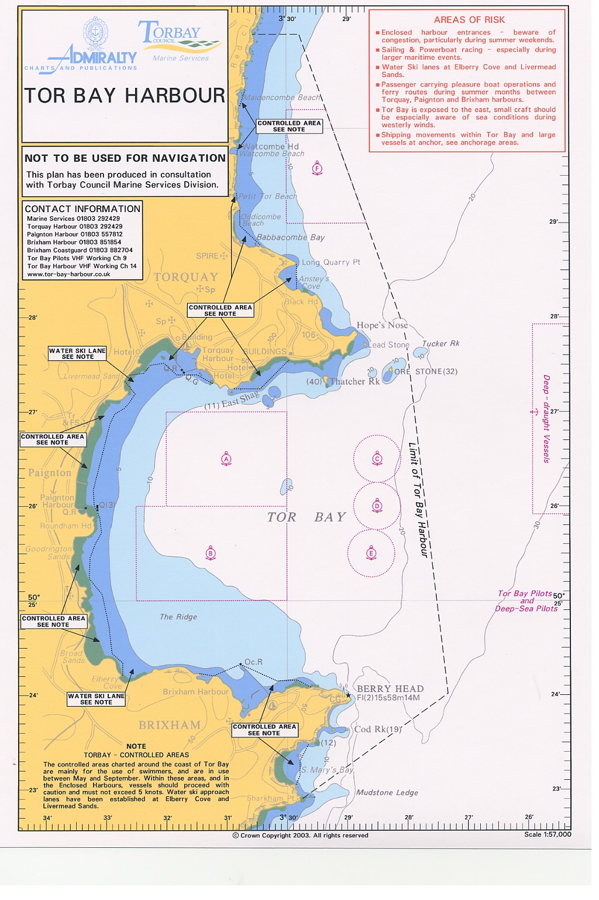

TORQUAY HARBOUR

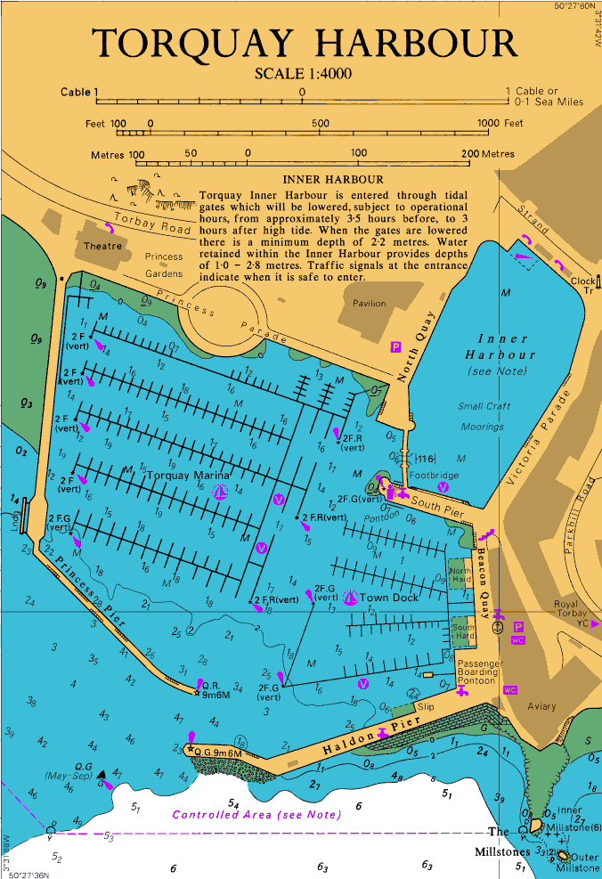
PAIGNTON HARBOUR

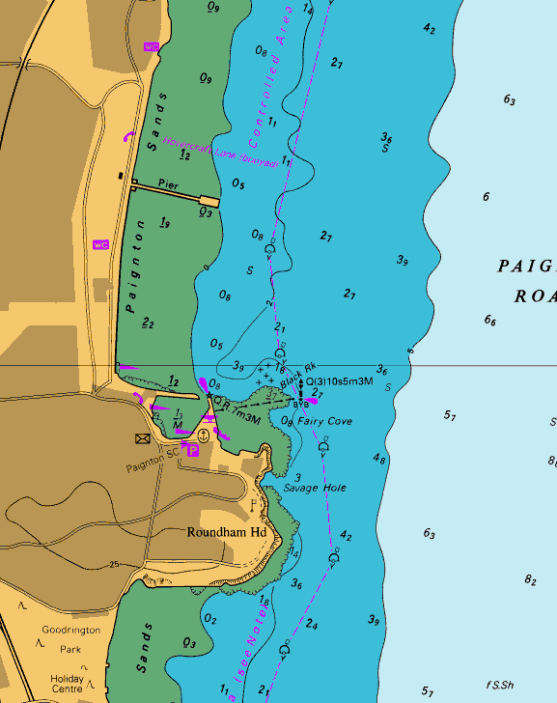
BRIXHAM HARBOUR

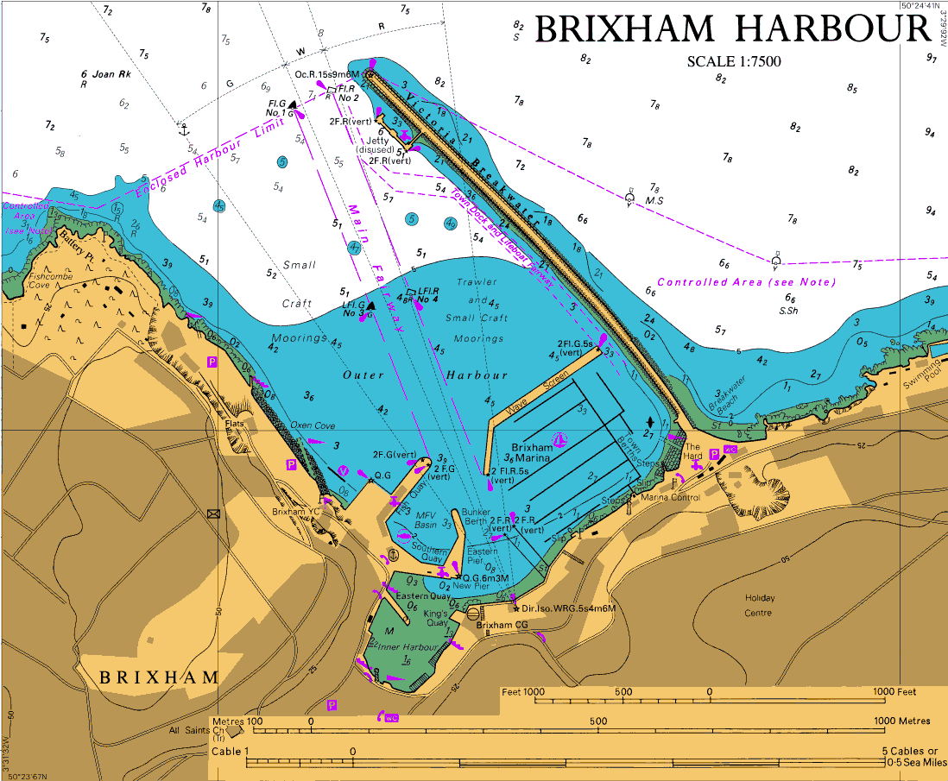

ANNEX B

TOR BAY HARBOUR AUTHORITY CONTACT

Name | Contact | Comments
Duty Harbour Master | TOR2 24-Hour Control  Tel 01803 550405  Fax 01803 402938  E-mail tor2occ@tor2.co.uk | Details for other Tor Bay Harbour Authority Staff held by:  - Duty Harbour Master  - TOR2 24-Hour Control  - Contact for all Torbay Council resources including Duty Harbour Master via Emergency Cascade

ANNEX C

COMMUNICATIONS PLAN

Location | Telephone | Fax | VHF | Comments
Torquay | 01803 292429 | 01803 299257 | Call Sign:  Torquay Harbour  Ch. 14 | Hours:  1 Oct – 30 April  Mon – Fri  0800 - 1700 local time  1 May – 30 September  0700 – 2100 local time
Brixham | 01803 853321/  851854 | 01803 852434 | Call Sign:  Brixham Harbour  Ch. 14 | Hours:  1 Oct – 30 April  Mon – Fri  0600 - 2200 local time  1 May – 30 September  0600 – 2200 local time
Paignton | 01803  557812 | 01803  520057 | Call Sign:  Paignton Harbour  Ch. 14 | Hours:  1 Oct – 30 April  Part-time  0900 - 1700 local time  1 May – 30 September  0800 – 1800 local time
Out of Hours contacts via TOR2 24-hour Control
01803 550405

VESSEL REPORTING
Vessels should report in accordance with the information provided in the Admiralty List of Radio Signals (ALRS).

ANNEX D

ANNEX C

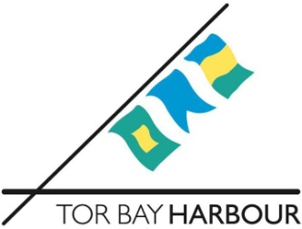

Spare

ANNEX E

TOR BAY HARBOUR AUTHORITY EMERGENCY OPERATIONS LOG
DATE |  |  | SHEET NUMBER
DIRECTORATE |  | SECTION/LOCATION |  |  | OPERATOR
TIME | INCIDENT |  |  | ACTION

ANNEX F

FAO: H.M.COASTGUARD

FROM: TOR BAY HARBOUR AUTHORITY

SUBJECT: POLREP CG77

REPORT BY: POSITION:

DATE:

A: CLASSIFICATION OF REPORT (i) Doubtful (ii) Probable (iii) Confirmed

B: DATE & TIME

REPORTED BY

C: POSITION:

D: TIDE / WIND

E: WEATHER & SEA STATE:

F: CHARACTERISTICS

G: SOURCE & CAUSE

H: VESSELS IN AREA

I N/A

J PHOTOGRAPHS/SAMPLES

K REMEDIAL ACTION

L FORECAST

M NAMES Tor Bay Harbour Master
Torquay DHM
Brixham DHM
Paignton HM
Torbay Council

N OTHER INFORMATION No

